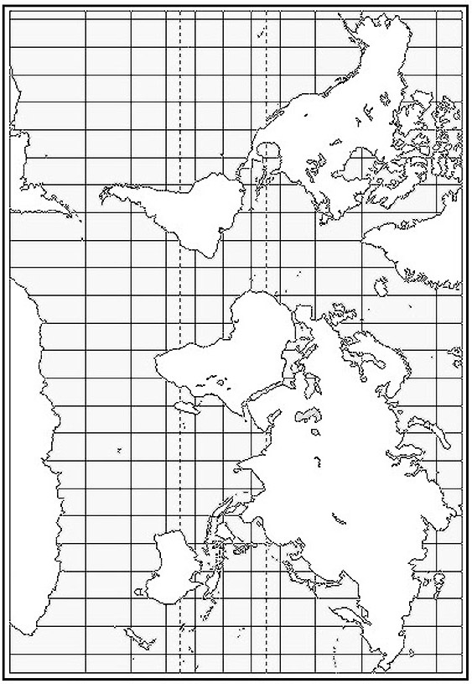
Name: _______________________________________________________ Class: 1 2 3 4 5 6

